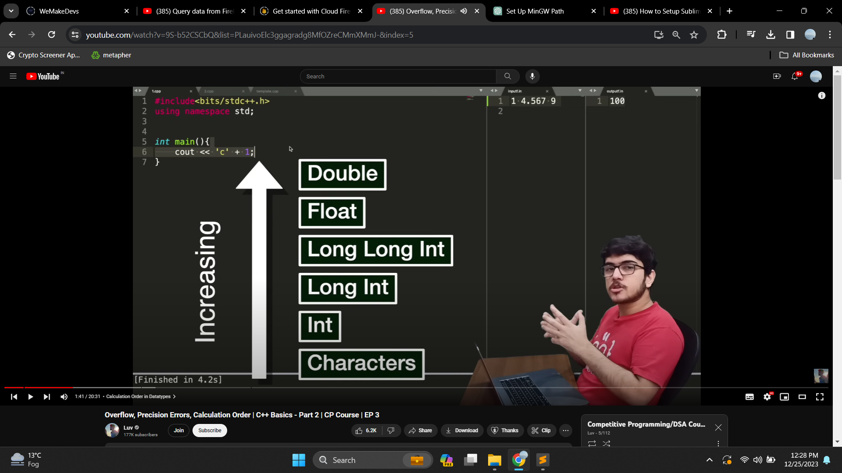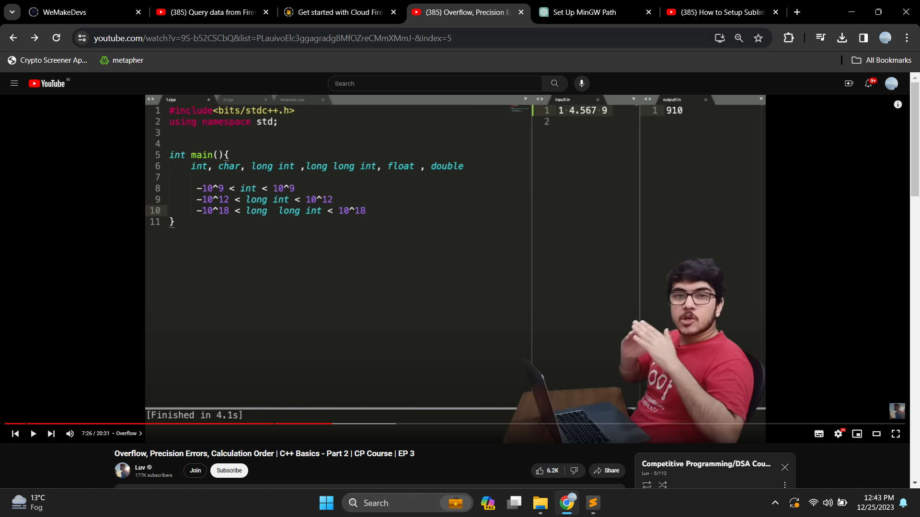

We should not use double for higher values as their precision is not good and we might get error

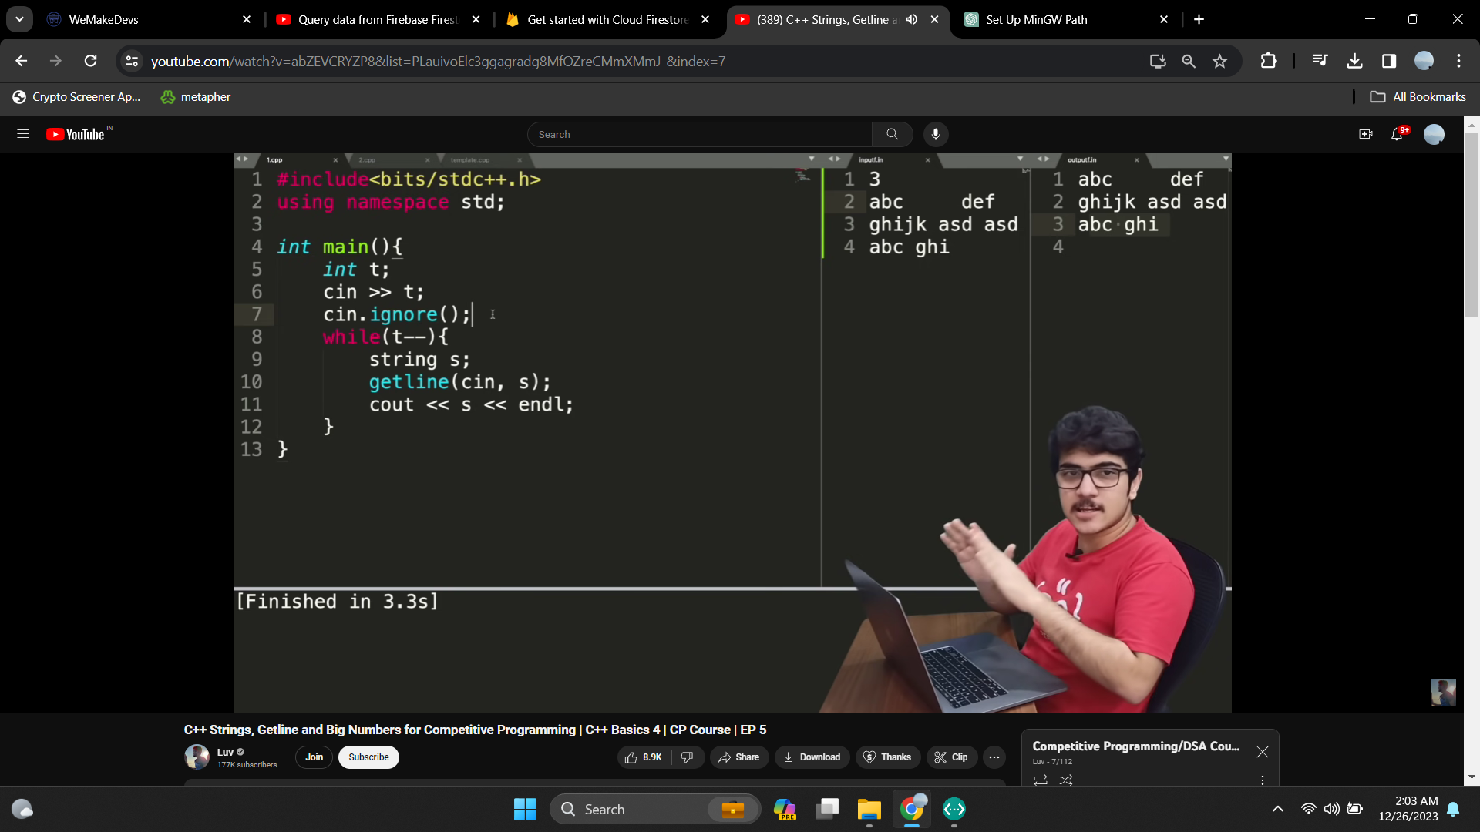

To get the input in the form of string and including spaces we should use the getline and cin<ignore

We should not add char to the string as it is expensive task instead of it we should use **str.push_back(“d”)**

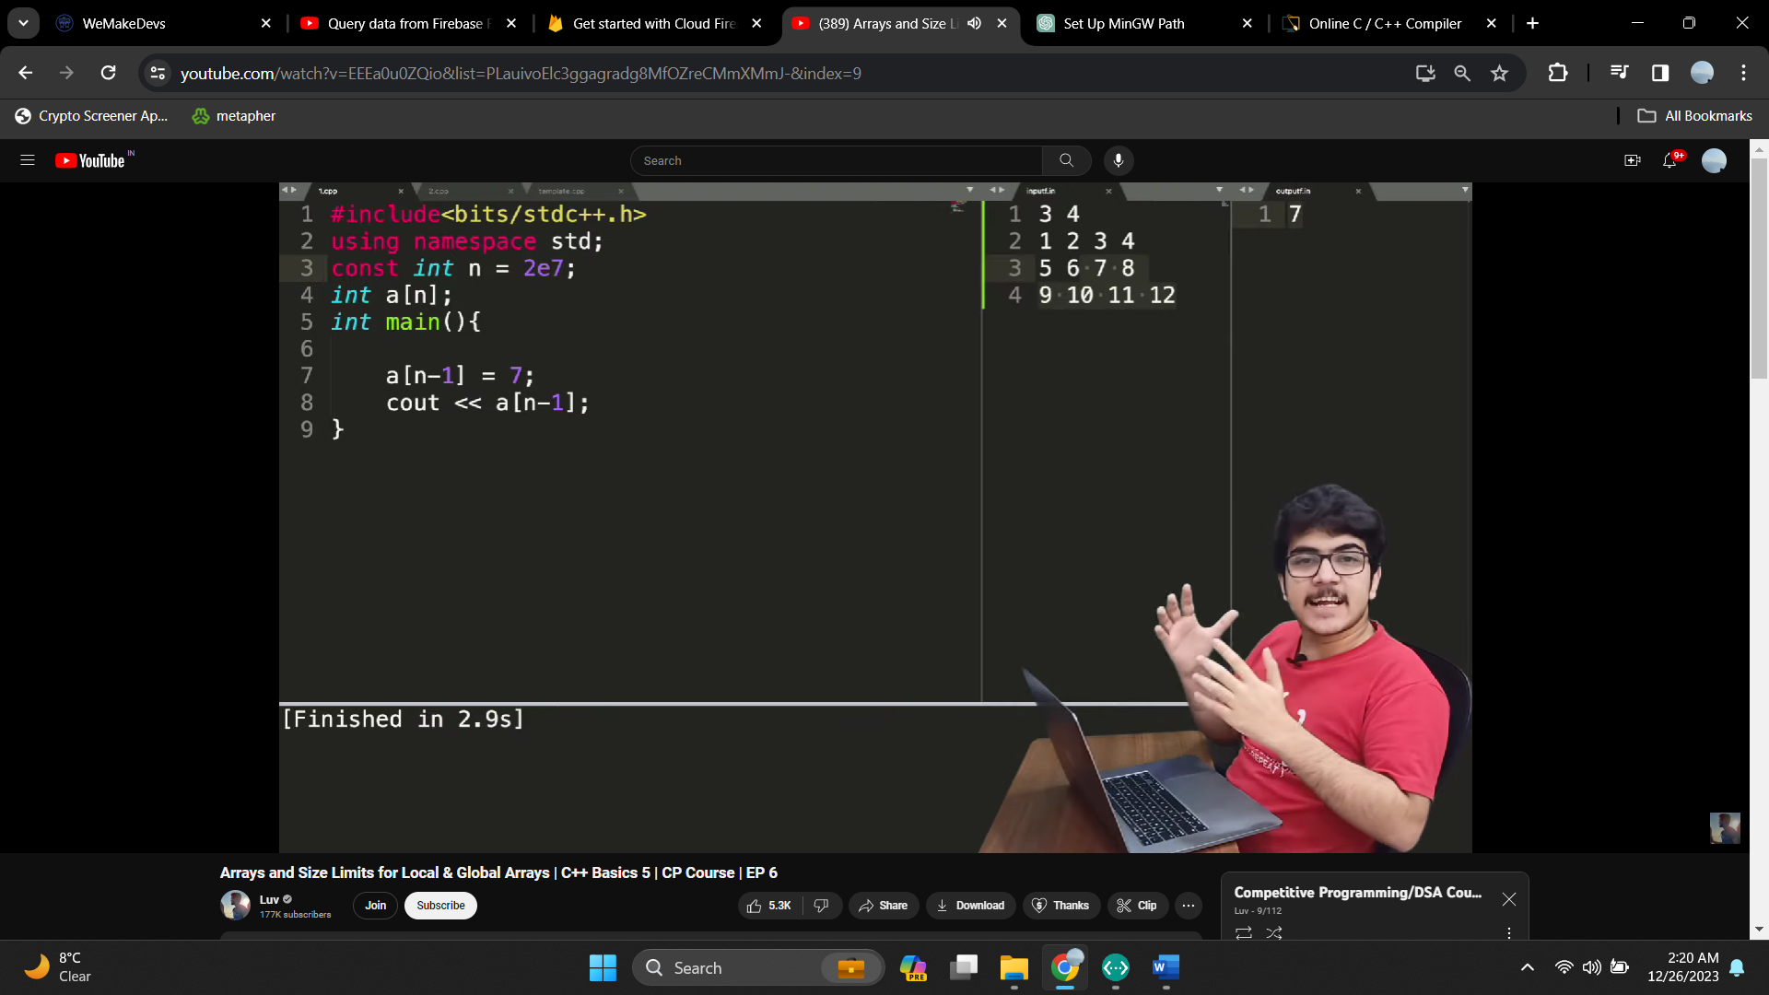

* **Cin does not take space as input means it will ignore the space meaning is aman deep cin will take only aman as input and ignore the remaining**
* **In global array we can make more than 1e7 in online platform**

-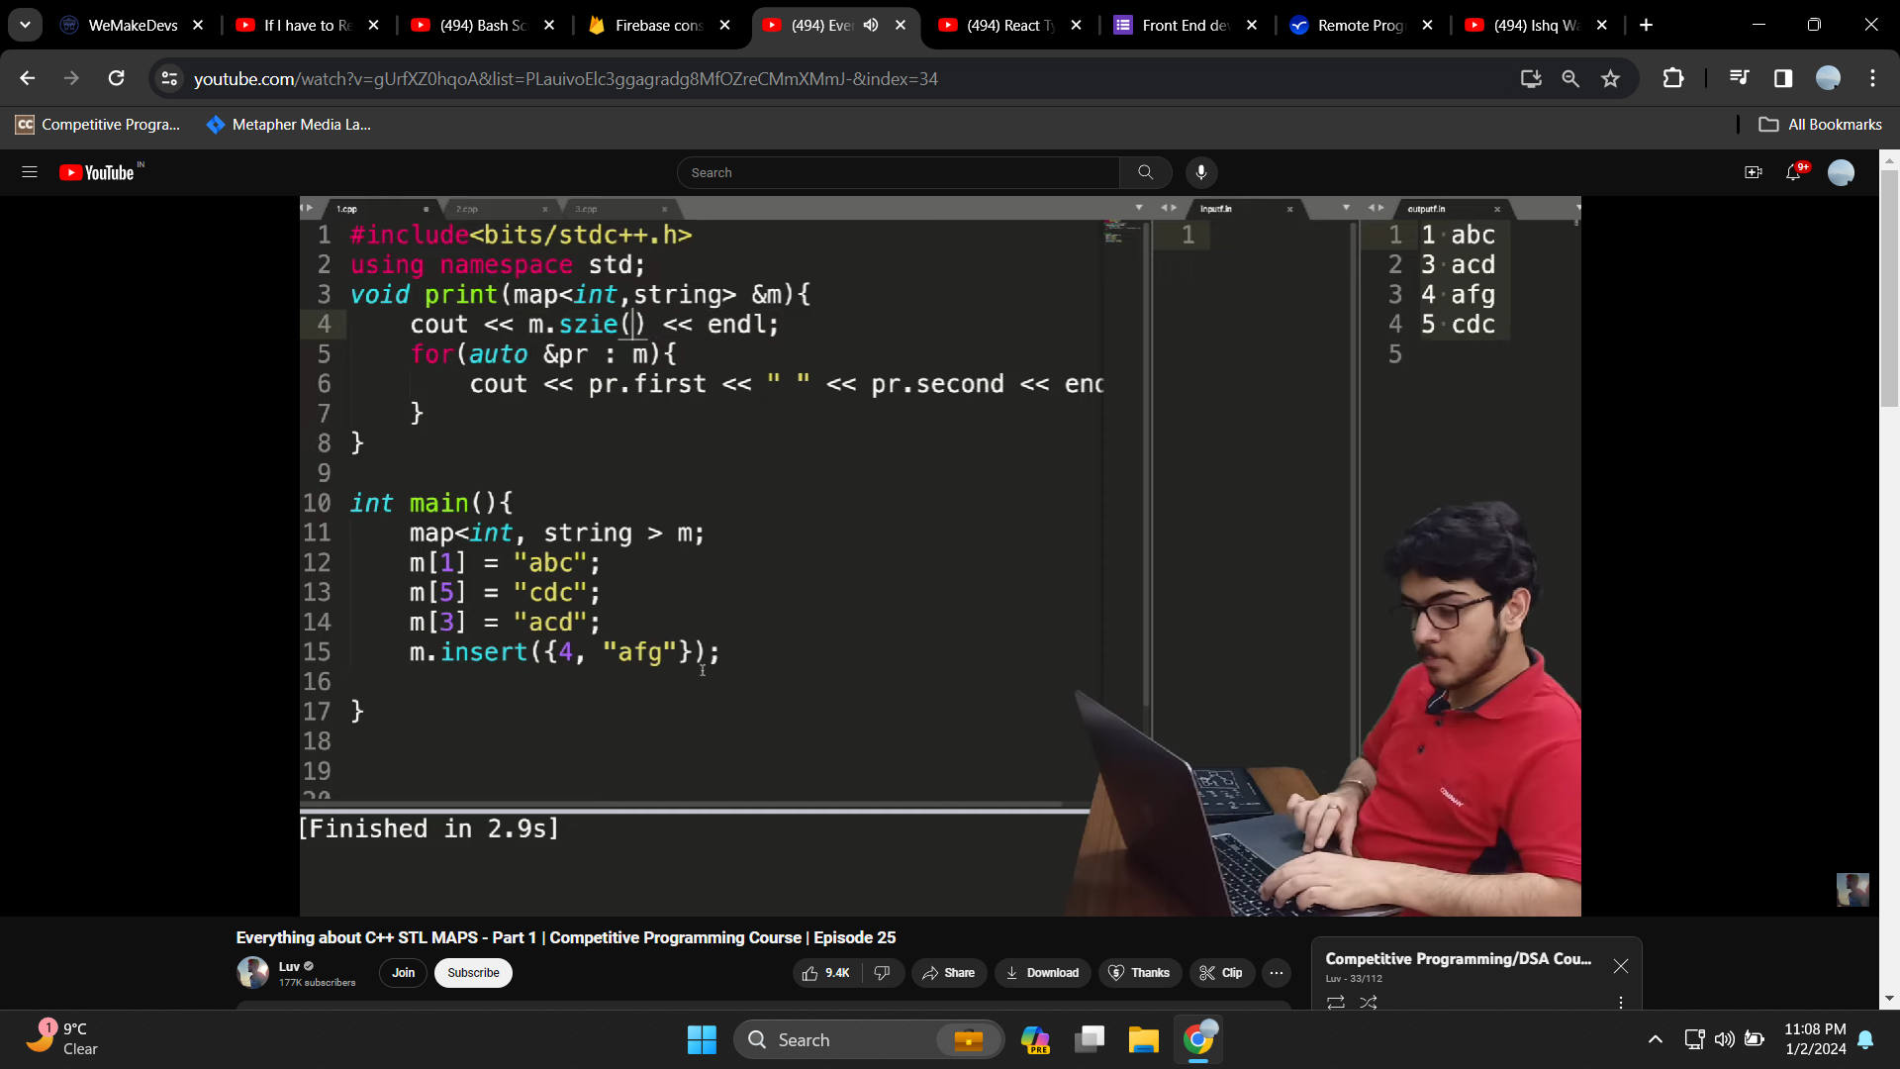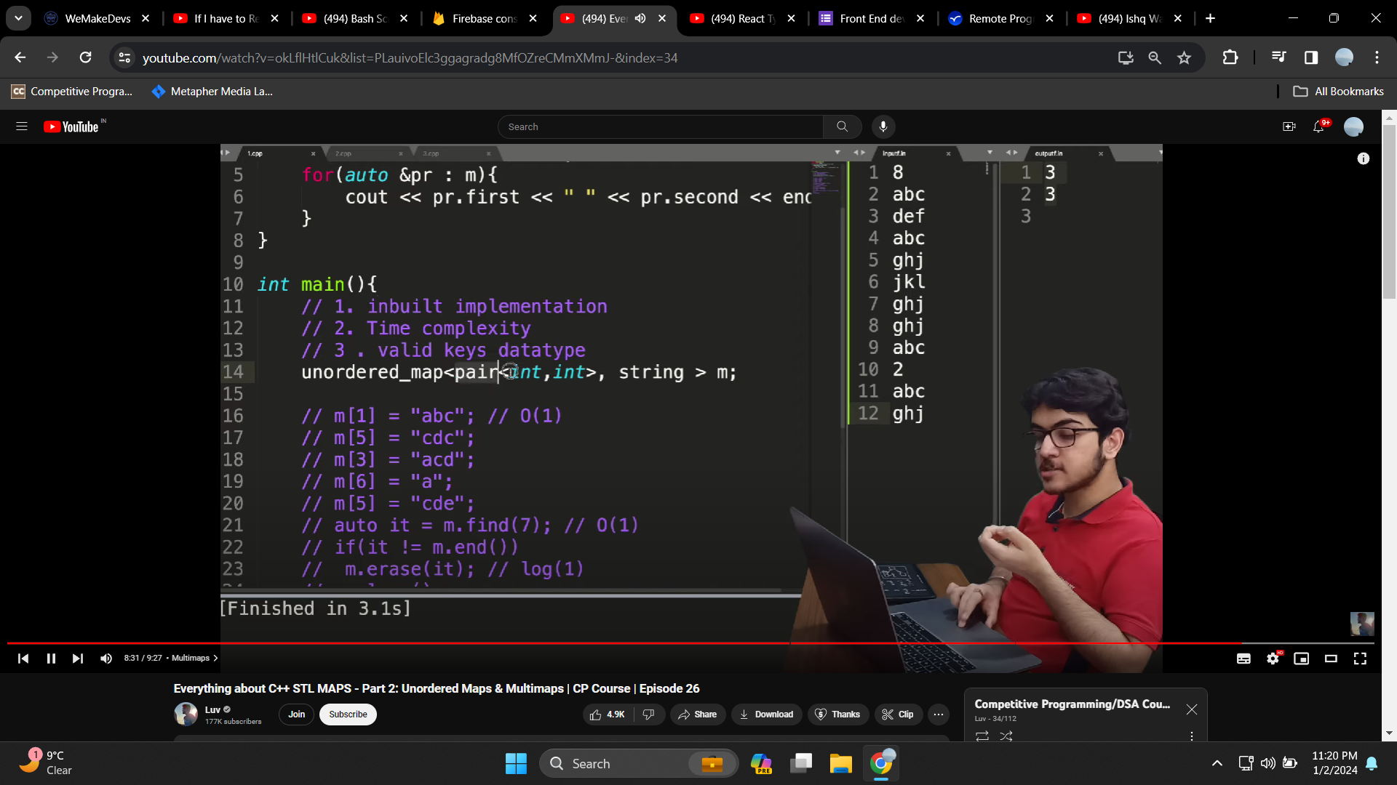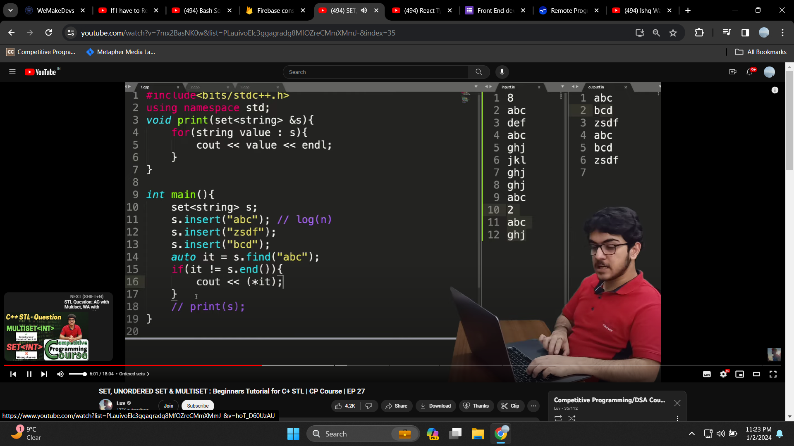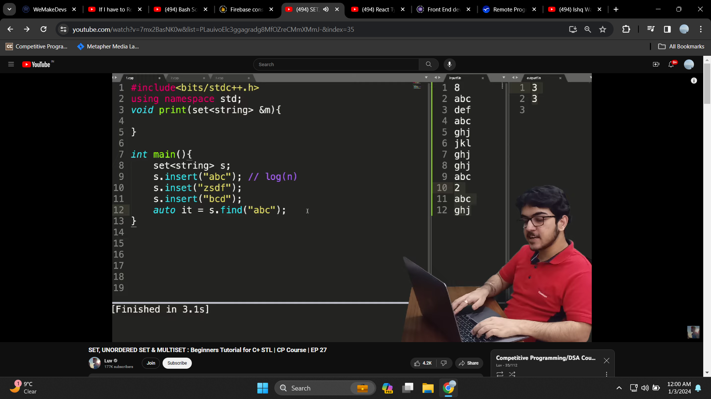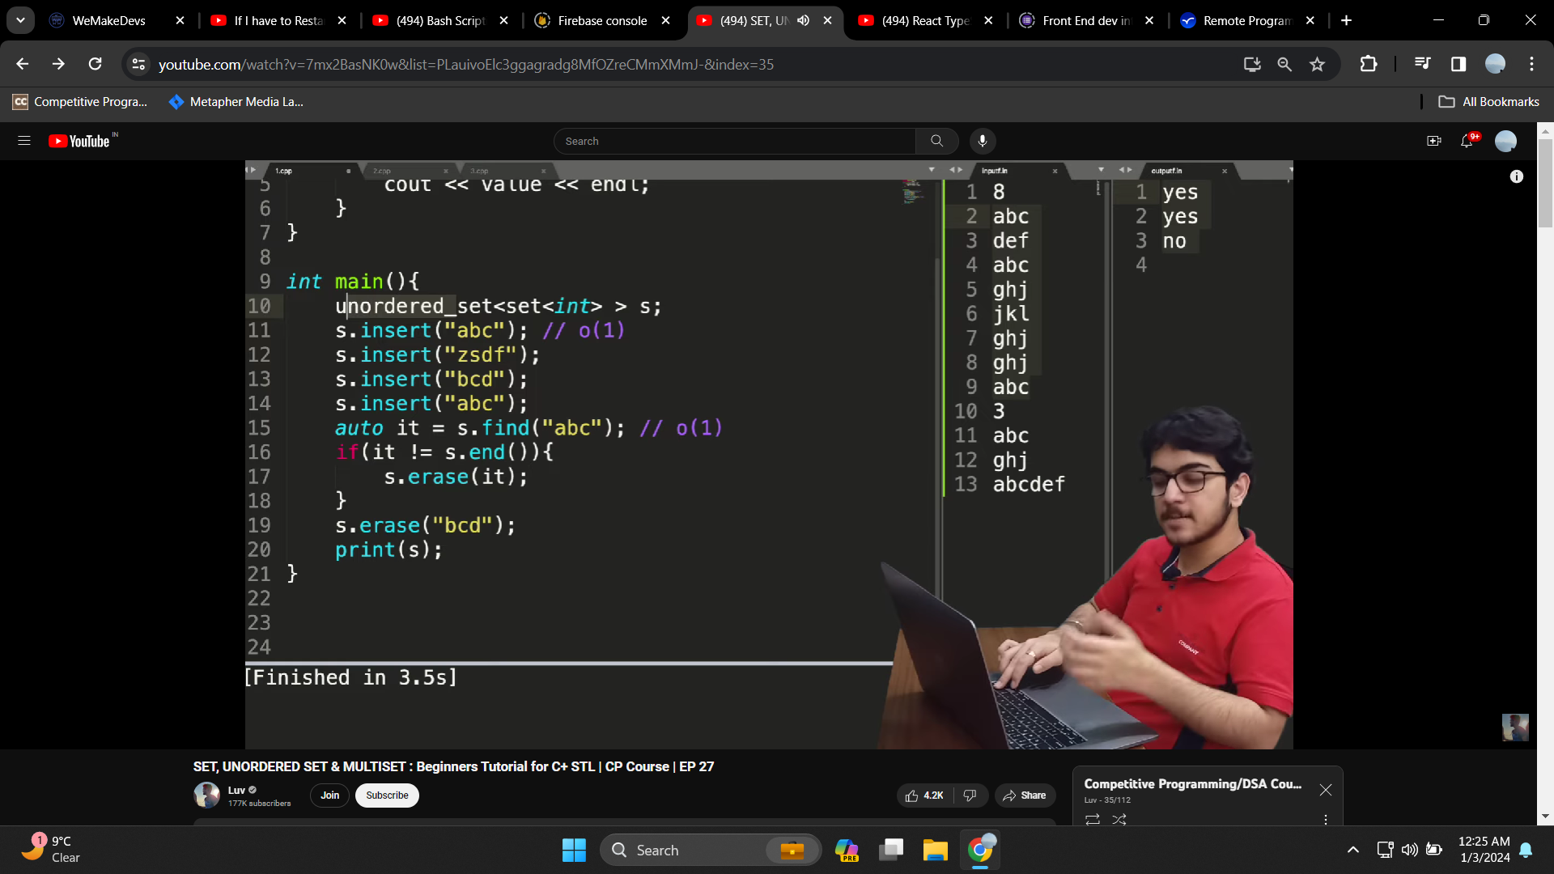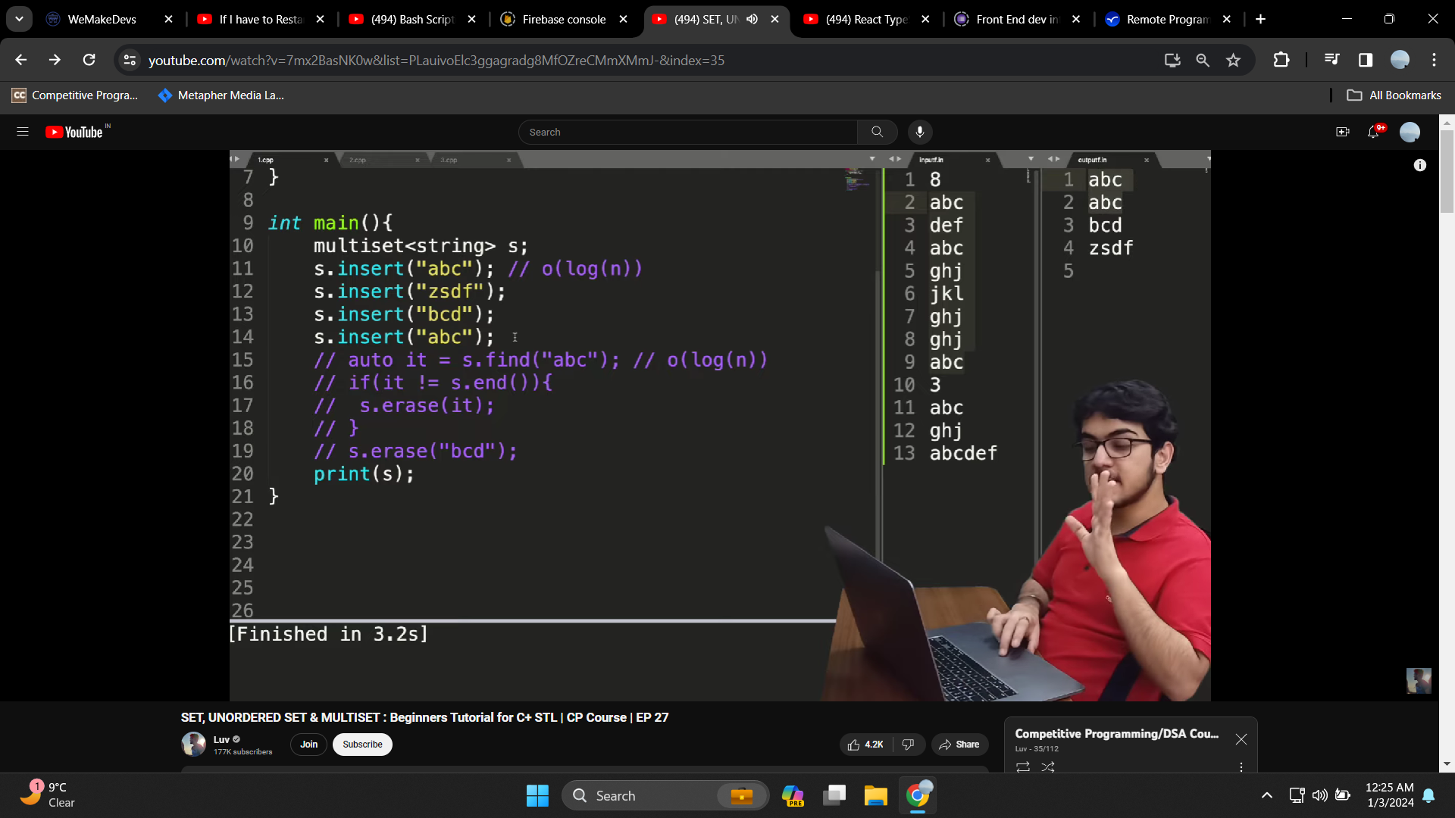

Using multiset if I want to remove some element then we can do it with v.erase(it) if it is iterator then only first value is erased if we pass value instead of iterator then all values present get deleted